As a member of American Board of Internal Medicine’s (ABIM)Governance, you play a vital role in determining what board certification should mean and helping ABIM reinforce core messages about our programs with the internal medicine community.

**LETTER TO ABIM GOVERNANCE**

Together, ABIM staff and Governance members have spent decades advancing internal medicine, continually innovating along the way. Recent innovations include co-creating exams and questions with robust physician input to ensure we adequately assess real-world medical knowledge, and introducing a lower-stakes, more convenient maintenance of certification assessment option.

**We are innovating again as we prepare to introduce the Longitudinal Knowledge Assessment (LKATM) to 12 internal medicine disciplines in 2022, with four more in 2023.**

The LKA is a new assessment created with physicians’ personal and professional needs in mind: greater flexibility, more convenience and faster feedback. The LKA gives board certified physicians the opportunity to maintain certification at their own pace, on their own schedule and without needing to take a point-in-time exam at a test center. What’s more, physicians will get instant feedback if they got a question right or wrong, along with references and rationales every time they answer a question, so they can more quickly apply what they’ve learned in practice. And because “life happens,” the LKA allows physicians to take breaks from answering questions when they need it.

**As we work to roll out the LKA, we’re asking you to help us spread the word via your professional networks**. This could entail taking to social media to reinforce key messages about LKA’s benefits, giving an elevator speech to a leader of your medical society or including an article in your organization’s newsletter, blog or website.

We want to ensure that every board-certified internist is aware of the LKA and the features and benefits it will provide. This toolkit provides materials and support to help you promote the LKA among your professional community in different ways. You may also learn more about the Longitudinal Knowledge Assessment by visiting [www.abim.org/lka](http://www.abim.org/lka).

The ABIM staff is always on hand to answer your questions and support your efforts. Simply contact John Held, Director of Communications and Brand Management at [jheld@abim.org](mailto:jheld@abim.org).

Working together, we can ensure the LKA is embraced by the diplomate community and broadly successful at giving physicians more convenience and choice, and most importantly, it helps them know and demonstrate they are keeping their medical knowledge current. Thank you for lending your time, talent and expertise to this important work.

Sincerely,

Richard J. Baron, MD, MACP

President and CEO

American Board of Internal Medicine

The Longitudinal Knowledge Assessment (LKATM) is a flexible Maintenance of Certification (MOC) assessment option that aims to address the needs of today’s practicing internists and subspecialists. The American Board of Internal Medicine (ABIM) co-created the LKA *with* physicians *for* physicians, engaging them throughout its development and ensuring their feedback was incorporated into the final product.

**ABOUT THE LONGITUDINAL KNOWLEDGE ASSESSMENT**

**The LKA is a wholly redefined, interactive assessment experience that also supports physicians’ ongoing educational efforts and makes it easier for them to know and demonstrate they are keeping up with advances in medicine.**

The LKA consists of a five-year cycle, featuring sets of 30 questions every quarter that can be answered a few at a time or all at once. Physicians work at their own pace during the quarter (unopened questions will expire at the end of the quarter), and will receive immediate feedback on their answers with rationales and references to help identify areas for future study, as well as feedback on their performance relative to the passing standard.

As long as diplomates open at least 500 of the 600 questions offered during the five-year cycle, they will meet the participation requirement, which includes flexibility to allow for short-term medical challenges, vacations, weddings, funerals, or other personal events.

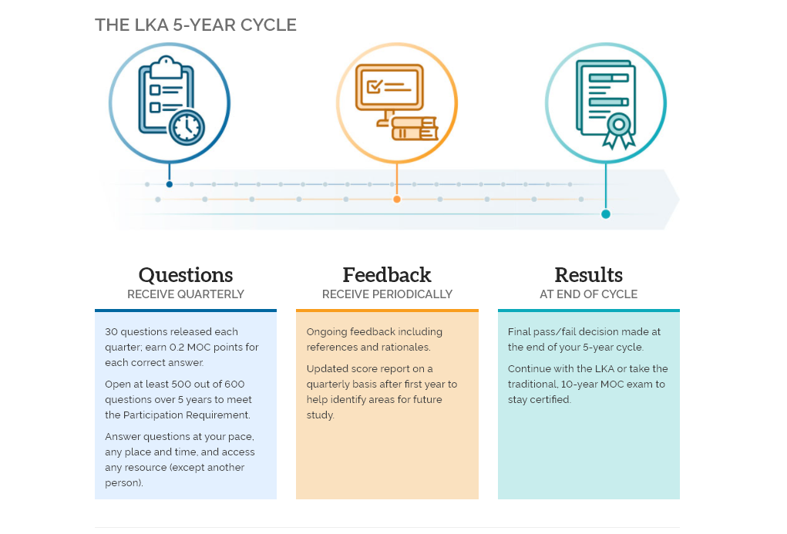

**MOC points can be earned through LKA participation**

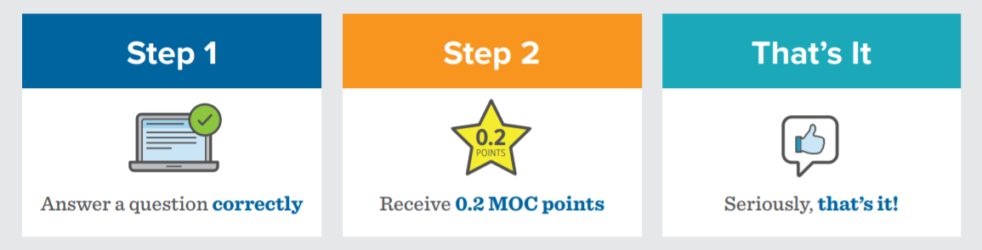

Physicians will earn 0.2 MOC points for every question answered correctly. And if you participate in LKA for more than one of your certificates you’ll still receive 0.2 MOC points for every correct answer, giving you even more opportunities to earn points. Remember: you only need to earn a total of 100 MOC points over 5 years, no matter how many certificates you’re maintaining.

**ABIM is working to make the LKA available to as many board-certified physicians as possible as quickly as possible, with 12 specialties rolling out in 2022, and four more in 2023.**

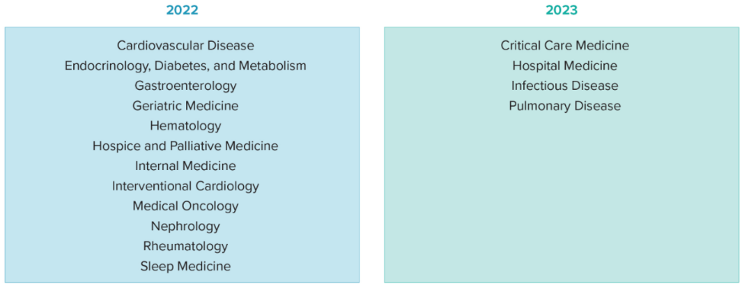12 specialities will launch in 2022, and four specialties particularly hard hit by the COVID-19 pandemic—Critical Care Medicine, Hospital Medicine, Infectious Disease and Pulmonary Disease—will launch in 2023 to allow more time to create content for a high-quality assessment.

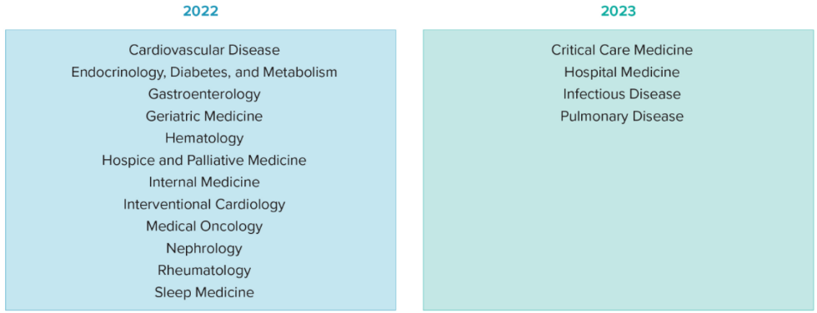The LKA requires substantially more items compared to the traditional, 10-year MOC exam and won’t be available in certain specialties (**Adult Congenital Heart Disease, Advanced Heart Failure and Transplant Cardiology and Transplant Hepatology**) because there are fewer physicians maintaining certification in these highly specialized areas. Clinical Cardiac Electrophysiology will not be available at launch but will be revaluated for 2024.

In Cardiovascular Disease, Advanced Heart Failure and Transplant Cardiology, Clinical Cardiac Electrophysiology and Interventional Cardiology, the ACC Collaborative Maintenance Pathway will be available.

All diplomates will continue to have the traditional, 10-year MOC exam available.

**Enrollment for the LKA opens on December 1, 2021.**

Physicians due for assessment in 2020, 2021 or 2022 in the available specialties will be eligible to enroll. The first set of questions will be delivered **January 4, 2022** and the **quarter ends March 31, 2022**, so enrolling early ensures physicians will have enough time to access and answer questions for that quarter. Physicians are encouraged to sign in to their personalized [ABIM Physician Portal](https://identity2.abim.org/identity/login?signin=5d06db2fa61946c004cb255a4e63d9bc) to check for upcoming deadlines and other program requirements. ABIM has also created an [Assessment Availability Tool](https://www.abim.org/maintenance-of-certification/assessment-information/assessment-options/longitudinal-knowledge-assessment/#year) to preview your assessment options in the future.

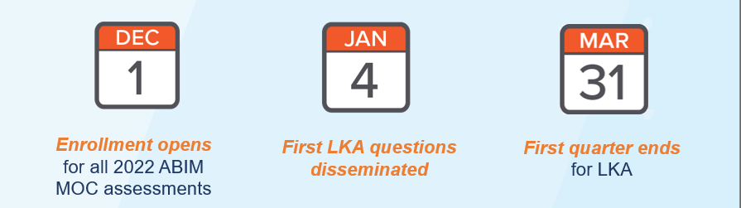

**The Knowledge Check-In (KCI) will no longer be available after 2021 as ABIM transitions to the LKA.**

As the KCI is offered on an every-other-year basis, for specialties that launched in an even numbered year, including internal medicine, 2020 was the last year it was available. The KCI will no longer be offered in any discipline after 2021. Learn more about [KCI availability on the ABIM website](https://www.abim.org/maintenance-of-certification/assessment-information/assessment-options/knowledge-check-in.aspx#rollout), and find assessment options by using the [assessment selector tool](https://www.abim.org/maintenance-of-certification/assessment-information/assessment-options/longitudinal-assessment.aspx#year).

**The LKA will be included at no extra charge under updated fee model effective 1/1/2022.**

ABIM certification sets those who earn it apart, and demonstrates to their peers and patients that they are an expert physician in their discipline. ABIM provides options for how physicians maintain their certification, giving them the flexibility to choose what works best for them while also giving them confidence they are keeping their medical knowledge current.

How physicians pay for Maintenance of Certification (MOC) will change in conjunction with the launch of the LKA, and there’s good news: beginning in 2022 the LKA will be **included in the annual MOC fee at no additional cost.**

**This means ABIM certified** **physicians will be able to choose an assessment option that allows them to pay less than they do today, as measured over a 10-year period**.

Here’s how it will work:

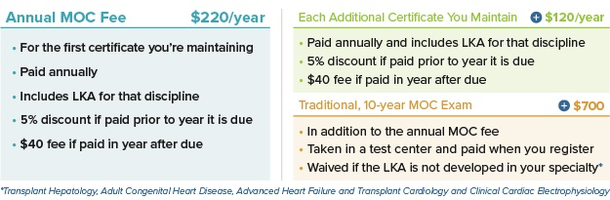

If any of your colleagues have questions about the updated fees and how it may affect them, please encourage them to contact ABIM’s Customer Relationship Advocates at 1.800.441.ABIM or [request@abim.org](mailto:request@abim.org).

**To learn more about the fees visit www.abim.org/mocfees.**

ABIM has developed a range of resources housed online to help Governance members spread the word about the LKA. PowerPoint slides or presentations are available upon request. Please email John Held, ABIM’s Director of Communications and Brand Management at [jheld@abim.org](mailto:jheld@abim.org) or David Buckman, Program Manager, Society and Governance Communications at [dbuckman@abim.org](mailto:dbuckman@abim.org) for assistance with presentations or any LKA communications.

**ONLINE RESOURCES**

* [Introductory Video](https://youtu.be/HgxwDQ-wNAU) (6:17)
* [Social Media-Friendly LKA Overview Video](https://www.youtube.com/watch?v=7boa64bMs8Y) (1:27)
* [LKA Launch in 2022: What You Need to Know Video](https://youtu.be/LlaHBO_kDyQ) (0:46)
* [Frequently Asked Questions](https://www.abim.org/maintenance-of-certification/assessment-information/assessment-options/longitudinal-knowledge-assessment/)
* [LKA Quick Reference Guide](https://www.abim.org/Media/mfumzfoj/e276-02-2021-lka-digital-brochure_final.pdf)

* [LKA Infographic](https://www.abim.org/Media/0wqpsmzc/longitudinal-infographic.pdf)
* [How to Earn MOC Points with LKA Flyer](https://www.abim.org/Media/k4shiv3x/lka-moc-points.pdf)
* [LKA Rollout Chart](https://www.abim.org/maintenance-of-certification/assessment-information/assessment-options/longitudinal-knowledge-assessment/#available)
* [About ABIM’s MOC Fees and Financial Transparency Video (2:37)](https://www.youtube.com/watch?v=-pIES0iOi6c)

*The talking points below can help you prepare for conversations about the LKA**with members of your professional networks.*

* ABIM’s new Longitudinal Knowledge Assessment (LKA) is launching in 12 disciplines in 2022, with four more becoming available in 2023. The LKAis an evolution in maintenance of certification (MOC) assessment that puts physicians in the driver’s seat with a lower-stakes, more flexible and convenient way to maintain ABIM board certification that helps them know they are staying current.

**ELEVATOR SPEECH**

* In 2022 ABIM will introduce the Longitudinal Knowledge Assessment as we continue to enhance the assessment experience and to include many features physicians have asked for – such as a remote testing option and access to resources used in practice. The traditional 10-year MOC exam will remain an option for those physicians who find it works better for them.
* During a five-year cycle, diplomates who choose the LKA receive 30 questions every quarter, which they can answer a few at a time or all at once. Any unopened questions will expire at the end of the quarter and can no longer be answered. These will count against the 100 total questions physicians don’t have to open over 5 years. Physicians can work at their own pace throughout the quarter, take questions whenever and wherever convenient, and receive immediate feedback if they got them right or wrong, along with rationales and references. Beginning in the second year physicians participating in the LKA will also get quarterly feedback on their performance relative to the passing standard.
* If physicians open at least 500 of the 600 questions during the five-year cycle, they’ll meet ABIM’s LKA Participation Requirement. It’s low-stakes: diplomates won’t lose their board certification if they don’t pass (as long as they are meeting other MOC requirements). They can take the traditional, 10-year MOC exam the following year and maintain their certification by achieving a passing score.
* Physicians will earn 0.2 MOC points for every question answered correctly.
* LKA questions can be answered on any internet-connected smartphone, tablet or computer. Some questions will contain media better suited for larger screens, and physicians will be alerted if a question contains media before opening it.
* Enrollment for the LKA opens on December 1, 2021. Physicians are encouraged to begin participating in the LKA in January 2022 so they have the maximum amount of time to take questions that quarter. The first quarter **ends March 31, 2022** and any unopened questions will not be scored and expire at the end of each quarter, meaning they can’t be answered later.
* Twelve specialties roll out in 2022 and four more will become available in 2023. Physicians due for an assessment in 2022 and in one of the 12 specialties launching next year are eligible. ABIM has created an [Assessment Availability tool](https://www.abim.org/maintenance-of-certification/assessment-information/assessment-options/longitudinal-knowledge-assessment/#year) to help physicians understand their assessment options.

*Please use this content to guide your development of a newsletter article or blog post addressed to your organization. It may also be used with organizations within your professional network, for example as a guest blog post.*The American Board of Internal Medicine (ABIM) is preparing to launch [the Longitudinal Knowledge Assessment](https://www.abim.org/lka/) (LKATM) in 2022, a new assessment option for maintaining board certification designed *for* physicians, *with* physicians to help them know and demonstrate they are keeping their medical knowledge current.

**TEMPLATE NEWSLETTER ARTICLE/BLOG POST**

The LKA features greater flexibility, more convenience, and real-time feedback. Physicians who participate in the LKA will receive 30 questions each quarter that can be answered at their own pace from any internet-connected smartphone, laptop or desktop. They can also reference all the resources from their practice, such as websites or personal notes – anything except for another person.

This new assessment supports physicians by providing immediate feedback if a question was answered correctly or not, along with references and rationales. Beginning in the second year, LKA participants will receive regular score reports to help identify areas for future study. Physicians will earn 0.2 MOC points for each question they answer correctly, up to 24 MOC points per year per certificate.

And because life happens, the LKA comes with built in flexibility for things like weddings, funerals, short-term medical issues, or if you simply need a break. As long as 500 out of 600 questions are opened during the five-year LKA cycle, physicians will have met the LKA Participation Requirement. A summative pass/fail decision is made at the end of the five-year cycle, and physicians cannot lose certification if they don’t achieve a passing score (as long as they are meeting other MOC requirements). If a physician doesn’t pass they can maintain their certification by taking and passing the traditional 10-year MOC exam the following year.

Enrollment for the LKA**TM** opens on **December 1, 2021**. The first set of questions will be delivered **January 4, 2022** and the **quarter ends March 31, 2022**, so enrolling early ensures physicians will have enough time to access and answer questions for that quarter. Twelve specialties roll out in 2022 and four more will become available in 2023. Learn more about eligibility, the roll out schedule and more at [www.abim.org/LKA](http://www.abim.org/LKA).

**SOCIAL MEDIA CONTENT**

*You can use the sample posts below to help you communicate about the LKA****TM*** *via major social media platforms.*

**Twitter**

* .@ABIMCert’s Longitudinal Knowledge Assessment – launching in 2022 – is a new and convenient assessment option to help you maintain your certification. Learn more: <https://www.abim.org/lka>
* In 2022 @ABIMCert will launch the Longitudinal Knowledge Assessment – a Maintenance of Certification assessment option designed by physicians, for physicians. Learn more: <https://www.abim.org/lka>
* The new Longitudinal Knowledge Assessment from @ABIMCert is designed to fit busy physicians’ schedules and needs. Check out the LKA’s features and benefits: <https://www.abim.org/lka>
* Learn about the features of @ABIMCert’s Longitudinal Knowledge Assessment in this great overview video: <https://youtu.be/7boa64bMs8Y>
* Did you know you can earn MOC points when participating in @ABIMCert’s Longitudinal Knowledge Assessment? Learn more: https://www.abim.org/Media/k4shiv3x/lka-moc-points.pdf
* .@ABIMCert’s Longitudinal Knowledge Assessment or LKA is a new way for physicians to maintain certification and know they are up to date with advances in medicine. Learn more: <https://www.abim.org/lka>
* Enrollment for @ABIMCert’s Longitudinal Knowledge Assessment opens Dec. 1. Learn more today: <https://www.abim.org/lka>

**Facebook**

* The new Longitudinal Knowledge Assessment from the American Board of Internal Medicine [tag] is an innovative assessment option created with physicians’ personal and professional needs in mind. It offers greater flexibility, more convenience, and instant feedback. Learn more about the Longitudinal Knowledge Assessment and how it can help you know and demonstrate you’re keeping your medical knowledge current: <https://www.abim.org/lka>
* Board certified physicians asked for a more convenient and flexible way to maintain their certification. The Longitudinal Knowledge Assessment is designed to meet the needs of today’s practicing physicians. Learn more about its features, eligibility, when to sign up and how it will work here: <https://www.abim.org/lka>

**LinkedIn**

* Internal medicine diplomates: In 2022 the American Board of Internal Medicine [tag] will roll out the Longitudinal Knowledge Assessment – a new assessment option to maintain board certification designed to meet the needs of today’s practicing physicians. The LKA lets physicians maintain certification on their schedule, at their pace and without the pressure of a high-stakes exam. Learn more <https://www.abim.org/lka>
* Now more than ever, it’s essential that internal medicine physicians have the flexibility and resources they need to maintain certification and stay up to date with the latest advances in medicine. ABIM’s Longitudinal Knowledge Assessment, was created with physicians’ personal and professional needs in mind. It offers greater flexibility, more convenience and faster feedback. Learn more about the LKA ahead of enrollment opening on Dec. 1: <https://www.abim.org/lka>